**READ ME FIRST**

1. Create a “Ryesim” folder in your D drive.
2. Download the soil source code to “D:\Ryesim\Soil Source”; download the crop source code to “D:\Ryesim\Crop Source”.
3. Compile as x64/Release
4. Download this “CALIBRATION_EXAMPLE” folder and save it in “D:\Ryesim”, i.e., under “D:\Ryesim\CALIBRATION_EXAMPLE”, you will see all the files,

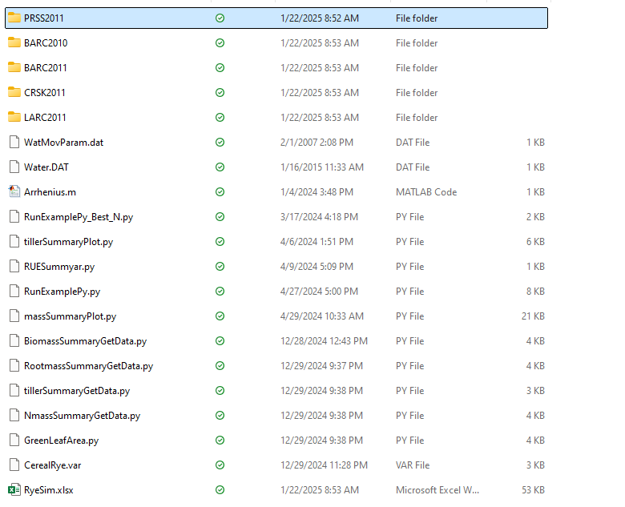

1. Use “RunExamplePy.py” to run all the examples.

There is an excel interface for ryesim as well. See the Excel interface folder. I modified the interface to create 2 level output folders, i.e, BARC2020\N_00 given only the Calibration_example folder exists

There is also a ‘run all grid files’ batch file to run all the grid1.bat files and generate the nodal information.